Visualization #3 and Presentation #4: Finding and Telling a Narrative from Data
Attached Files:
File BEA Auto-Light Truck Sales.xlsx (I uploaded it on separate document, check download 4)
For this Communication Challenge, you will demonstrate your ability to present results from a data analysis. You should clearly emphasis a narrative from the data.
Scenario & Receiver(s):
The leadership team of the National Automobile Dealers Association (NADA) has asked you for a fresh interpretation of the attached dataset (Bureau of Economic Analysis’s Auto and Light Truck Sales Data). NADA’s leaders are particularly interested in outside perspectives and potential narratives (either positive or negative) that could emerge from the dataset.
Specifics:
- Review and analyze the attached dataset (BEA Auto-Light Truck Sales.xlsx)
- Identify and develop your key message(s) and present them by following a traditional narrative arc. Among other things, you may consider: What makes your narrative compelling? How does the data support it? How would it be received?
- Using the dataset, create at least one data visualization to support your claim. Consider the concepts we have already discussed in what makes an effective visualization.
- Write a narrative (an exact speech you are going to use on your presentation) explaining the data visualization(s) that you created (should be about 400-500 words). It’s a 5-minute story.
Evaluation:
Holistic evaluation will be assessed based on the criteria outlined above and the quality of the narrative presented. Rubrics for professionalism, clarity, conciseness and the use of evidence are also provided and will be used for supplementary evaluation of your work.

Evaluation for this assignment will be based on the attached visualization checklist (created by Stephanie Evergreen). Please note, the checklist will be used to guide evaluation, but will not be used specifically as a rubric. All grades and comments will be derived from relevant points of the checklist and best principles and practices discussed throughout the course

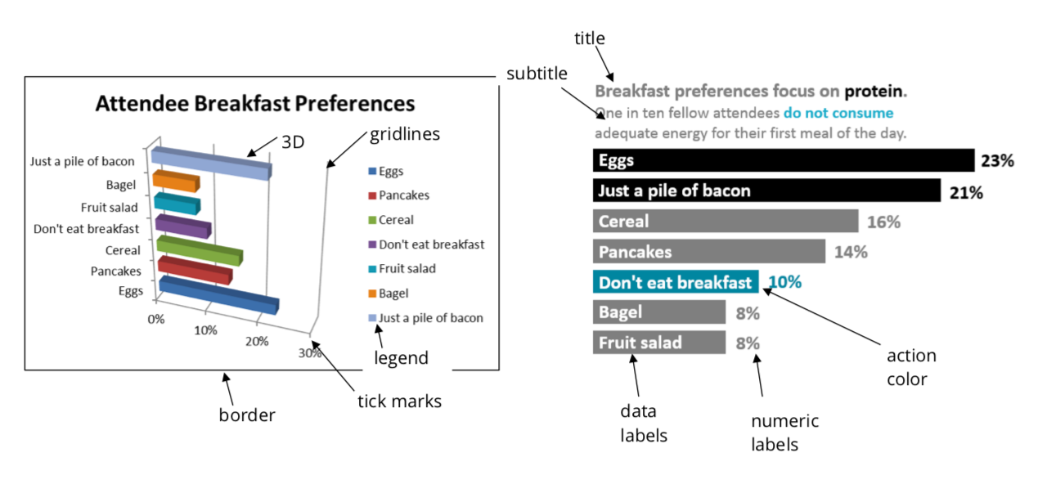
Examples of data visualization that you can create:

The narrative arc: starting at the beginning, moving towards the climax, and then ending in a resolution.

Narrative arc structure (in picture):

